CANDIDATE NAME ___________________________ REG. NO. ____ CLASS_________
 | DUNMAN HIGH SCHOOL (SENIOR HIGH)  YEAR 6 Preliminary Examination 2010
 | H2 CHEMISTRY  Paper 3 Free Response | 9647/03  16 September 2010  2 hours
Additional materials:
Cover Sheet
Writing Papers
Data Booklet

INSTRUCTIONS TO CANDIDATES
Write your name, register number and class on this question paper and on the Cover Sheet provided.
Write in dark blue or black pen on both sides of the paper.
You may use a soft pencil for any diagrams, graphs or rough working.
Do not use staples, paper clips, highlighters, glue or correction fluid.

Answer any four questions.
Start each question on a fresh sheet of paper.
A Data Booklet is provided.
You are reminded of the need for good English and clear presentation in your answers.

The number of marks is given in brackets [ ] at the end of each question or part question.
At the end of the examination:
- Fasten all work securely together with the Cover Sheet on top.
- Hand in the question paper separately.
The total marks for this paper is 80 marks.

Answer any four questions.

1(a) | Aluminium is the world’s most abundant metal and is the third most common element, comprising 8% of the earth’s crust. The versatility of aluminium makes it the most widely used metal after steel. Although aluminium compounds have been used for thousands of years, aluminium metal was first produced around 170 years ago.  - It is possible to ionise aluminium to form aluminium negative ion Al– in the gaseous state. Give a balanced equation for this reaction.  - What is the name of the reaction in (i)?  - Give the full electronic configuration of Al–.  - How would you expect the magnitude of the enthalpy change of the reaction in (i) to compare to that of sodium? Explain as fully as you can.  [6]
(b) | Solid aluminium chloride sublimes at 6000 °C. When 1.00 g of the solid is placed in an evacuated vessel of volume 1.00 dm³ at 6000 °C, the pressure produced is 207.7 kPa.  - Calculate the apparent relative molecular mass of the aluminium chloride under these conditions.  - Assuming that, in the vapour phase, aluminium chloride partially exists as dimer, calculate the percentage of the dimer under these conditions.  - Draw a diagram to show the bonding in the dimer of aluminium chloride.  [4]
(c) | The Gattermann–Koch reaction, named after the German chemists Ludwig Gattermann and Julius Arnold Koch in organic chemistry, refers to a Friedel–Crafts acylation reaction in which carbon monoxide and hydrochloric acid are used in–situ with Friedel–Crafts catalyst, namely AlCl₃. The reaction involves an acylium ion as an electrophile and tetrachloroaluminate ion, AlCl₄–. An example is provided below.  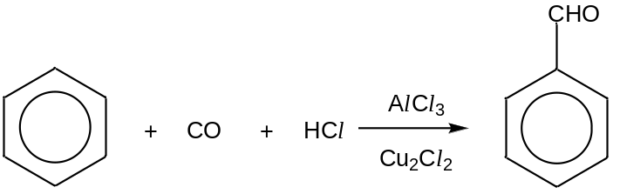  - Define the term electrophile.  - Give the forumla of the acylium ion in this reaction.  - State the type of reaction and describe the mechanism of Gattermann–Koch reaction (You may omit the step that generates the acylium ion).  [6]
(d) | The synthesis of compound C involves the Gattermann–Koch reaction in Step II. Complete the reaction scheme below by providing the appropriate reagents and conditions for  Step I and IV and give the structural formula for A – B.  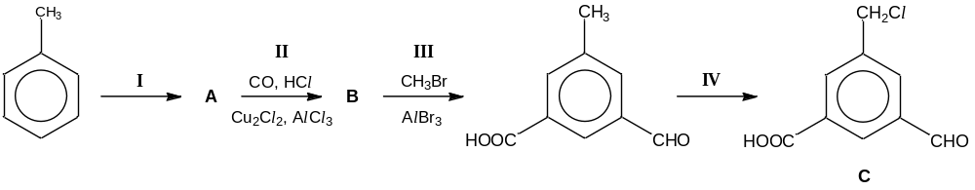  [4]  [Total: 20]
2(a) | Methane is used to produce synthesis gas (syngas), a mixture that includes carbon monoxide and hydrogen, by reacting with steam on a nickel catalyst. Syngas is then used to produce liquid hydrocarbons and methanol.  CH₄(g) + H₂O(g) CO(g) + 3H₂(g)  When a 1:1 ratio of methane and steam at a total initial pressure of 10 atm is mixed, 50% conversion is achieved.  - Write an expression for the equilibrium constant, K_{p}, and determine its value, including units.  - It is known that this reaction is an endothermic process. What is meant by the term in italics?  - Predict and explain the effect of separately increasing pressure and decreasing temperature on the above equilibrium as well as on the yield.  - In practice, a moderately high pressure is used in the production of syngas. Suggest a reason for this.  - Sketch a graph showing how the rates of the forward and reverse reactions change with time, from the point of mixing to the point after equilibrium is established. Label your graphs clearly.  [11]
(b) | To manufacture methanol, the carbon monoxide and hydrogen mixture is passed over a mixutre of copper, zinc oxide and alumina catalyst. Besides being a common laboratory solvent, the largest use of methanol (CH₃OH) is to produce methanal (HCHO).  - Industrially, oxygen is used to react with methanol to produce methanal. Write an equation for this reaction.  - Alternatively, what reagent and condition can be used in the laboratory to convert methanol to methanal?  - Sketch the shapes of the hybrid orbitals around each carbon in the methanol and methanal molecule.  [4]
(c) | Methane reacts with a chlorinating agent, sulfur dichloro dioxide (SO₂Cl₂) by a free–radical mechanism to yield choromethane in the following equation.  CH₄ + SO₂Cl₂ → CH₃Cl + CH₃SO₂Cl + SO₂ + HCl  - The initiation stage of this reaction occurs in two steps, both of which form the chlorine radical. Write an equation for each step at this stage.  - Propose two equations to represent the propagation stage of this reaction.  - Given that CH₃SO₂Cl is produced at the termination stage, write the formulae of the radicals that produce it.  [5]  [Total: 20]
3(a) | The dry cell battery is commonly used in portable devices such as handphones and torch lights. It is a non–rechargeable battery, with zinc electrode coated with Zn(OH)₂ and solid MnO₂ coated on carbon electrode. During the discharging process, MnO₂ is converted to MnO(OH) solid and hydroxide ions. The relevant redox half–equations are given in the table.
  Half–equation | Eº / V
  MnO₂ + e⁻ + H₂O MnO(OH) + OH⁻ | +0.84
  Zn(OH)₂ + 2e Zn + 2OH– | –0.76
- By means of a fully labelled diagram, describe how the value of the standard electrode potential of the Zn(OH)₂/Zn system can be confirmed.

- Write an overall equation for the discharging reaction and calculate the cell voltage of the dry cell.

- What happens to the voltage of the dry cell when water is added to the zinc half cell? Explain your answer.

- State one advantage of using this dry cell over a lead–acid accumulator.

- Explain why compounds of zinc are colourless.
[11]

(b) | Besides their use in dry cell batteries, compounds of manganese also have applications in organic chemistry. In particular, potassium manganate(VII) is a useful oxidising agent.  When methanal, HCHO, is reacted with acidified potassium manganate(VII), methanoic acid and manganese(II) ions are formed. The overall equation for the reaction is:  2MnO₄–(aq) + 5HCHO(aq) + 6H⁺(aq) → 2Mn²⁺(aq) + 5HCOOH(aq) + 3H₂O(l)  The methanoic acid formed can be further oxidised to carbon dioxide.  At room temperature, the reaction proceeds at a slow rate. A few crystals of vanadium(III) nitrate are added to the mixture to speed up the reaction, which results from the formation of vanadate(IV) ions, VO²⁺, as intermediate.  - Calculate the oxidation number of carbon in HCOOH.  - Briefly describe the role of vanadium(III) ions in this reaction.  (iii) Referring to relevant values from the Data Booklet and from the data given, show how vanadium(III) ions act as a catalyst in the reaction. Include balanced equations in your answer.  HCOOH(aq) + 2H⁺(aq) + 2e HCHO(aq) + H₂O(l) Eº = –0.03 V  [5]
(c) | In an attempt to produce manganese metal, a student carried out the electrolysis of an aqueous solution of manganese(II) sulfate.  - Predict the product(s) of the reaction at the cathode. Explain your reasoning using data from the Data Booklet.  - Calculate the current needed to pass through a solution of manganese(II) sulfate to produce 0.1 g per hour of the product at the cathode.  [4]  [Total: 20]

4(a) | Caprolactam, C₆H₁₁NO, is a cyclic precursor to nylon 6, a widely used synthetic polymer.  An undergraduate student attempts to prepare caprolactam using 6–aminohexanoyl chloride, H₂N(CH₂)₅COCl.
(i) Draw the structural formula of caprolactam which could be obtained from
6–aminohexanoyl chloride. Name the type of reaction that is involved.

(ii) In the presence of 5 – 10% water and heating 6–aminohexanoyl chloride to about
80 °C, the student isolated compound A, which has a molecular formula of C₁₂H₂₄N₂O₃, instead of caprolactam. Upon prolonged heating at a higher temperature of 250 °C, compound A is converted to a polymer, nylon 6. The structure of nylon 6 is shown below.

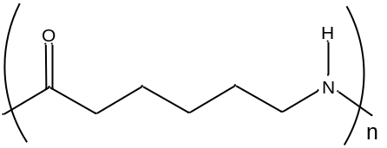
nylon 6

Draw the structural formula of compound A.

(iii) The step–growth polymer nylon 6 can be hydrolysed to its monomer. Suggest a possible structural formula for its monomer and state the necessary reagent and condition for the conversion.
[5]

(b) | Phenyl–4–aminosalicylate is a drug used in the treatment of tuberculosis. It can be synthesised from 4–nitrosalicylic acid.  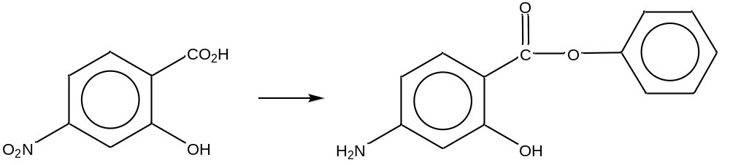  4–nitrosalicylic acid phenyl–4–aminosalicylate  Phenyl–4–aminobenozate,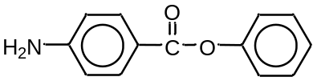, a structural analogue of phenyl–4–aminosalicylate, can be prepared in a similar way from 4–nitrobenzoic acid.  (i) Outline how phenyl–4–aminobenzoate may be produced from 4–nitrobenzoic acid.  (ii) Suggest a chemical test to confirm that phenyl–4–aminobenozate has been formed.  (iii) Explain why 4–nitrobenzoic acid has a higher solubility in water than 4–nitrosalicylic acid.  (iv) Draw a diagram of 4–nitrobenzoic acid to illustrate how the shape and bond angles of its nitro group differ from that of the nitronium ion, NO₂⁺ and nitrite ion, NO₂–.  [11]
(c) | Dilute solutions of 4–nitrobenzoic acid behave as weak acids. Aqueous 4–nitrobenzoic acid of concentration 0.1 mol dm^{–3} is only 8% dissociated into its ions.  (i) Calculate the pH of 0.1 mol dm^{–3} 4–nitrobenzoic acid.  (ii) Write a K_{a} expression for the acid and define the term pK_{a}.  (iii) Calculate the pK_{a} value.  [4]  [Total: 20]

5(a) | 2–chloroethanal, CH₂(Cl)CHO, more commonly known as chloroacetaldehyde, is normally used in the control of bacteria and fungi in water and also as a starting reagent to synthesise other organic compounds.  Chloroacetaldehye can be used as a starting material for the synthesis of  3–hydroxypropanoic acid. Propose a reaction scheme, in not more than 3 steps, for this conversion. Your answer should include the reagents and conditions, as well as the structures of the intermediate compounds formed.  [3]
(b) | A student conducted an experiment by reacting chloroacetaldehyde and ethanoyl choride separately with aqueous silver nitrate. It was observed that only ethanoyl choride produced a white precipitate with aqueous silver nitrate.  - Explain this observation, writing balanced equations where necessary.  - Describe and explain what will be observed when the white precipitate is added to excess aqueous ammonia.  [4]
(c) | The liquid–phase oxidation of acetaldehyde, CH₃CHO, at 65 °C is used to produce ethanoic acid commercially, with cobalt or manganese ethanoate dissolved in ethanoic acid as a catalyst. With the aid of a suitable diagram, explain how cobalt or manganese ethanoate acts as a catalyst to increase the rate of this reaction.  [3]
(d) | J is an organic compound with molecular formula C₁₀H₁₃O₂Br. 1 mol of J reacts with 3 mol of aqueous Br₂ to produce a white precipitate K, C₁₀H₁₀O₂Br₄. When refluxed, 0.015 mol of J requires 30 cm³ of 1.0 mol dm^{–3} of aqueous NaOH to produce L and an ionic salt NaBr. However J does not react with aqueous sodium carbonate. Reaction of L with hot acidified KMnO₄ produces M with formula C₁₀H₁₂O₃. All three compounds J, L and M produce a yellow precipitate N when warmed with alkaline aqueous iodine. M forms an orange precipitate with 2,4–dinitrophenylhydrazine but does not react with silver(I) diammine complex.  - Suggest structures for J – N and explain the chemistry involved. Write a balanced equation for the reaction of compound L with aqueous alkaline iodine.  - Explain with an equation, what will be observed when chlorine gas is bubbled into an aqueous solution of the ionic salt NaBr.  [10]  [Total: 20]

BLANK PAGE

